Project on POS Tagging

Part of Speech (hereby referred to as POS) Tags are useful for building parse trees, which are used in building NERs (most named entities are Nouns) and extracting relations between words. POS Tagging is also essential for building lemmatizers which are used to reduce a word to its root form.

POS tagging is the process of marking up a word in a corpus to a corresponding part of a speech tag, based on its context and definition. This task is not straightforward, as a particular word may have a different part of speech based on the context in which the word is used.

**For example:**In the sentence “Give me your answer”, answer is a Noun, but in the sentence “Answer the question”, answer is a verb.

**The Different POS Tagging Techniques**

There are different techniques for POS Tagging:

1. **Lexical Based Methods — A**ssigns the POS tag the most frequently occurring with a word in the training corpus. In other words, the tag encountered most frequently in the training set with the word is the one assigned to an ambiguous instance of that word. The problem with this approach is that while it may yield a valid tag for a given word, it can also yield inadmissible sequences of tags.
2. **Rule-Based Methods —**Assigns POS tags based on rules. For example, we can have a rule that says, words ending with “ed” or “ing” must be assigned to a verb. Rule-Based Techniques can be used along with Lexical Based approaches to allow POS Tagging of words that are not present in the training corpus but are there in the testing data.
3. **Probabilistic Methods —**This method assigns the POS tags based on the probability of a particular tag sequence occurring. Conditional Random Fields (CRFs) and Hidden Markov Models (HMMs) are probabilistic approaches to assign a POS Tag.
4. **Deep Learning Methods** — Recurrent Neural Networks can also be used for POS tagging.

**POS Tagging using CRF**

Please use following link for POS tagging using CRF. <https://medium.com/analytics-vidhya/pos-tagging-using-conditional-random-fields-92077e5eaa31>

**Understanding the Recurrent Neural Network**

A class of artificial neural network where connections between units form a directed graph along a sequence. This allows it to exhibit dynamic temporal behaviour for a time sequence. Un-like feedforward neural networks, RNNs can use their internal state (memory) to process sequences of inputs. This makes them applicable to tasks such as unsegmented, connected handwriting recognition or speech recognition.

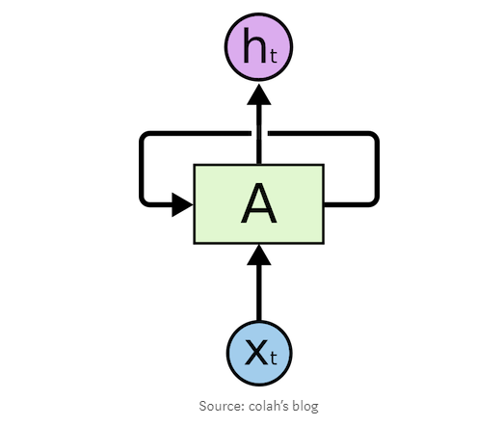

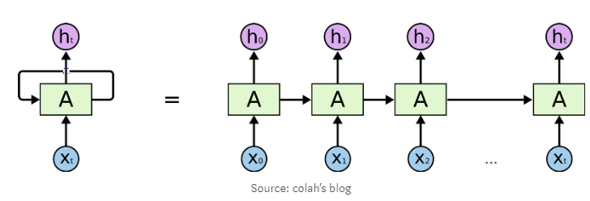

RNN helps wherever we need context from the previous input.

**The following are the few applications of the RNN:**

* Next word prediction.
* Music composition.
* Image captioning
* Speech recognition
* Time series anomaly detection
* Stock market prediction